**Test 25082021**

1. Email – Audit creation
   1. Logo is weird (for all received emails) -> Can we change to CAA logo?
   2. The link does not work -> Can you confirm this is because it is the test session?

1. Client view – documents submission
   1. Align the submit and cancel buttons so there is an equal space above and below

1. Client view – after submitting the documents
   1. Change the button color to dark green
   2. Can the content be managed from the Admin panel? :
   3. Octal: Yes (On platform setting ==> Audit conformation)

1. Admin – User list / User deletion
   1. On the right, there is a display issue (logos are coming out of the page)
   2. When deleting a user, the pop up on the top right is weird. Change to “User successfully deleted”
   3. After deleting a user (company)
      1. I can still login with the company login and PW that are supposed to be deleted
      2. The admin can still create an audit for this company (Seb Testing Co)

1. Admin view – Documents view (in the audit tab)
   1. Change the header from Document upload for “[quote number]” to: Documents uploaded for [audit type] audit ref (quote) #[quote number]
   2. Back button in grey

1. Admin view – Auditors assignment
   1. Change header to Confirm the audit date and assign the auditor(s) for the [audit type] ref (quote) #[quote number]

1. Auditor view – Audits
   1. Replace the column Quote number with Company
   2. Change icon colors as discussed previously
   3. Move the chat icon in second position from the left

1. Admin view – Create new audit
   1. Change title to Create a new audit

1. Auditor view – Start new audit
   1. Change wording to Do you confirm you are starting the [audit type] audit ref (quote) #[quote number] for [company name]?

1. Auditor view – audits list
   1. The icon “View documents” should not be available before the audit has started

1. Auditor view – view documents
   1. Change header to Documents uploaded by [company name]

1. Auditor view – request additional documents
   1. Change to: Please confirm you are sending a request for additional documents from [company name].

1. Auditor view – audits
   1. Icons ‘View documents’ and ‘Other documents’ are the same. They should be different
   2. Other documents should be ‘Additional Documents’
   3. Once the client has uploaded additional documents, the auditor is not able to ask more. The auditor needs to be able to ask for additional documents several times

1. Auditor view – additional documents
   1. Change title to Additional documents uploaded by [company name]
   2. Change back button color to grey
   3. Remove the search section on this page
   4. Columns header and content do not match

1. Auditor view – chat
   1. The small popup for the chat needs to show the company name instead of 75094131
   2. Change the color of the number from blue to red (for the client view as well)

1. Admin view – audits
   1. Add new button in dark green
   2. Reset button in grey
   3. Change ‘Other documents to ‘Additional documents’
   4. Need a different icon for additional documents
   5. All icons need to be grey, except assign auditor
   6. Change ‘Quote number’ with ‘Ref (quote)’
   7. Remove ‘Signed by’ column, replace with ‘Lead auditor’

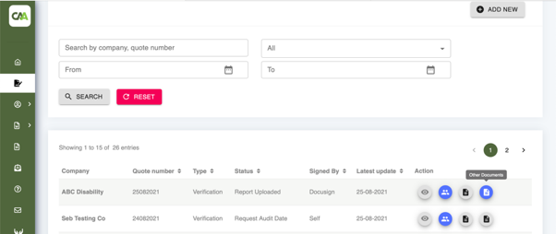

1. Auditor view – Rejection reasons
   1. Add one line in between each reason
   2. Add the date for each rejection reason
   3. In the case below, the 3rd reason should be on several lines. Enable the possibility to type several lines
   4. There should be no characters limit on the client side (currently capped at 150 characters)

1. Admin view – Send report to NDIA
   1. Change title to ‘Send report to NDIA’
   2. Change text to: Confirm you have sent the report to NDIA for the [audit type] audit ref (quote) #[quote number].
   3. Button colors: Yes in dark green, cancel in grey
   4. When clicking out of the window, it should be the same as cancel

1. Admin view – audit completed
   1. When the audit is completed, the admin needs to be able to view the documents, in addition to the report

1. All views – Audits
   1. Change the description of the ‘View’ icon to ‘Audit details’

1. Client view – Audit
   1. Change Audit Request to Audit Details
   2. Remove the search function
   3. On the left panel change Audit Request to Audit Details
   4. Reorder the buttons on the left panel in the following order:
      1. Dashboard
      2. Audit Details
      3. Upload Documents
      4. Transactions
      5. Key Personnel
      6. My Account
      7. Notifications (instead of Notification)

1. Client view – Key Personnel
   1. Change search button to grey
   2. Change Definition of Key Personnel button to grey
   3. Change Add New button to dark green
   4. Change 3 icons to grey
   5. Change ‘Registered ‘At with ‘Registered On’

1. Client view – Transactions
   1. Remove the search function
   2. Column headers and content do not match (bring the actions to the left)
   3. Change download icon color to grey
   4. Audit column should show [audit type] audit ref (quote) [quote number]

1. Admin view – left side
   1. Change Audit Request to Audit Management
   2. Change Manage Documents to Documents Management
   3. Add Notifications

1. Admin view – Contact us
   1. How do we update this?

1. Auditor view – Dashboard
   1. Left box: Total number of audits assigned by CAA
   2. Middle box: Number of audits completed
   3. Right box: Number of audits in process

Left bar:

Change ‘Audit Request’ to ‘Audits’

Change ‘Notification’ to ‘Notifications’

Bring My Account to the bottom

